LAB 5: DC ULTRA SYNTHESIS TECHNIQUES

OUTLINE
I. Design Specification
II. Lab Instructions
Task 1. Synthesis of RTL design containing pipelines
Task 2. OPTIONAL: Formal Verification

Design Schematic
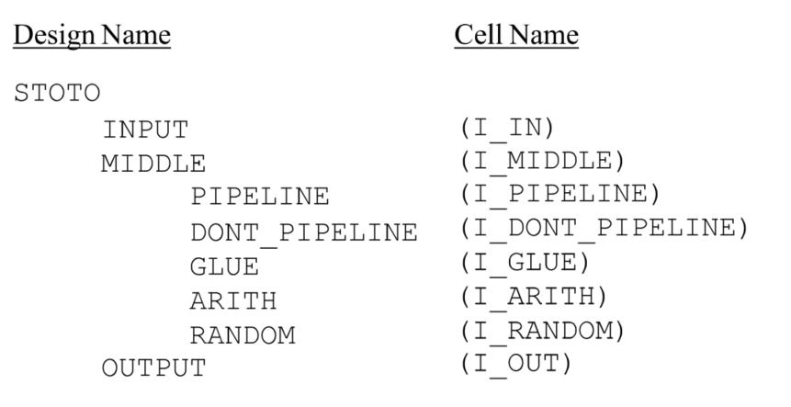
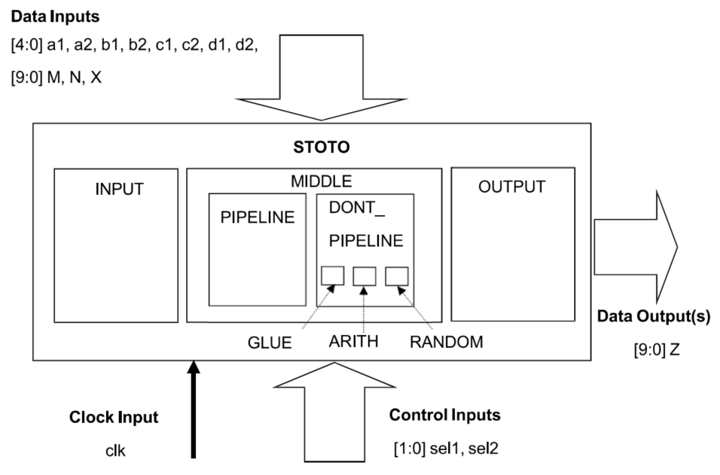
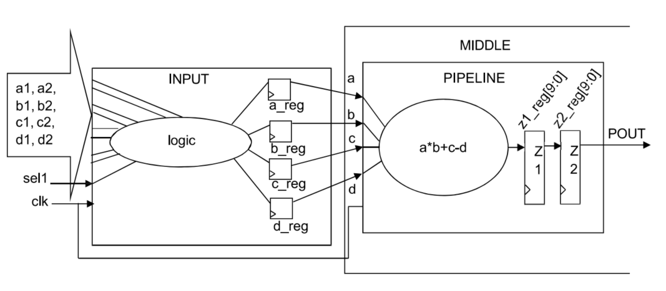
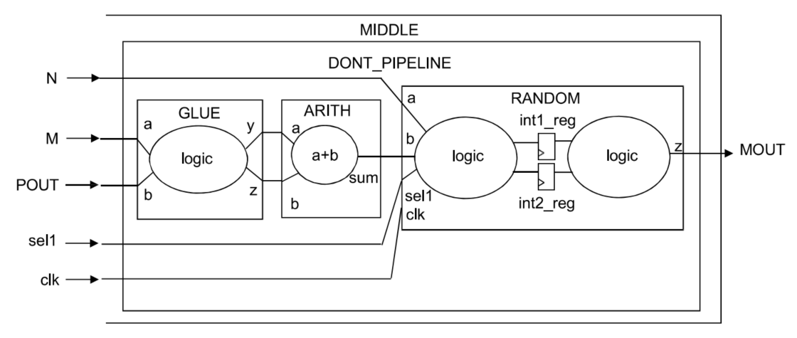
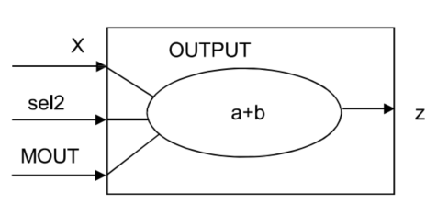

I. Design Specification
DESIGN SPECIFICATION | COMMAND AND  COMMAND EXPLANATION
1. The I/O constraints are estimates and have been conservatively constrained | Command:  source ./scripts/STOTO.con  Explantion:  + The source command reads and applies all timing and environmental constraints defined in the external file STOTO.con.  + This file already includes the clock, uncertainty, input delay, output delay, and load definitions required for synthesis.  + Using a constraint file ensures all design I/O conditions are applied consistently and conservatively, preventing early timing violations during synthesis.
2. The final compiled design must meet setup timing on all internal register-to-register paths | Command:  group_path –name INPUTS –from [all_inputs]  group_path –name OUTPUTS –to [all_outputs]  group_path –name COMBO –from [all_inputs] –to [all_outputs]  group_path –name clk –critical_range [expr 2.1 * 0.1] -weight 5  Explantion for each command:  Command 1:  group_path –name INPUTS –from [all_inputs]  + Creates a timing group called INPUTS for all paths starting from the input ports.  + This helps Design Compiler analyze and optimize timing between inputs and internal registers.  Command 2:  group_path -name OUTPUTS -to [all_outputs]  + Defines a timing group OUTPUTS that includes all paths ending at the output ports.  + Allows the tool to check register-to-output setup timing and ensure proper delay balancing.  Command 3:  group_path –name COMBO –from [all_inputs] –to [all_outputs]  + Defines a COMBO path group that includes all input-to-output combinational paths.  + Helps in reporting and analyzing any direct combinational timing violations.  Command 4:  group_path –name clk –critical_range [expr 2.1 * 0.1] -weight 5  + Creates a clk timing group to represent all register-to-register paths under the main clock.  + -critical_range [expr 2.1 * 0.1] defines the critical slack range as 10% of the 2.1 ns clock period (0.21 ns).  + -weight 5 increases optimization priority for paths near the clock’s critical range, ensuring setup timing closure for the main sequential logic.
3. The INPUT block hierarchy should be preserved to facilitate post-synthesis verification | Command:  set_ungroup [get_designs INPUT] false  Explantion:  + The set_ungroup command prevents Design Compiler from flattening the INPUT block during synthesis.  + This maintains the hierarchical structure between RTL and gate-level design.  + Keeping hierarchy helps in debugging and verifying the design after synthesis, as the module boundaries remain intact.
4. The PIPELINE block contains a “pure” pipelined design | Command:  set_optimize_registers true -design [get_designs PIPELINE]  Explantion:  + The set_optimize_registers command allows Design Compiler to perform register balancing and retiming inside the PIPELINE block.  + It ensures that registers are relocated internally for improved timing without changing functional pipeline behavior.  + This keeps the block as a “pure” pipelined structure with proper register separation between logic stages.
5. The output (POUT[9:0]) of PIPELINE must remain registered | Command:  set_dont_retime [get_cells I_MIDDLE/I_PIPELINE/z2_reg*] true  Explantion:  + The set_dont_retime command prevents Design Compiler from moving or removing registers associated with the z2_reg outputs of the PIPELINE block.  + This ensures that the block’s outputs remain fully registered, preserving the integrity of pipelined output timing and functionality.
6. The logic positions of registers in the instance or cell I_DONT_PIPELINE are fixed and cannot be modified | Command:  set_dont_touch [get_cells I_MIDDLE/I_DONT_PIPELINE/*]  Explantion:  + The set_dont_touch command disables any optimization, restructuring, or retiming within the I_DONT_PIPELINE block.  + This preserves both logic and register positions exactly as designed, ensuring consistency with previously verified functionality.
7. DRC violations should be fixed unless they prevent setup timing constraints from being met | Command:  Set_cost_priority -delay  Explantion:  + The set_cost_priority command controls the optimization goal of Design Compiler.  + Using -delay prioritizes timing optimization (setup closure) over fixing minor DRC issues such as transition or capacitance violations.  + This ensures that setup timing remains the top priority during synthesis.
8. The logic position of registers may be modified to improve timing, except where expressly prohibited or handled differently by above specs. | Command:  compile_ultra -spg -retime  Explantion:  + The -retime option enables adaptive retiming, allowing automatic relocation of registers to improve setup timing.  + The -spg option (Synopsys Physical Guidance) activates physically-aware synthesis, using placement estimation to achieve better timing correlation with layout.  + Together, these options allow Design Compiler to perform intelligent retiming while respecting the set_dont_retime and set_dont_touch constraints applied earlier.
9. Scan insertion will be performed by the “Testgroup” after the design has met these specifications | Command:  compile_ultra -scan  Explantion:  + The -scan option prepares the design for test-ready synthesis by replacing flip-flops with scan-capable versions, without connecting scan chains.  + This makes the design DFT-ready for the Testgroup to complete scan insertion later.

II. Lab Instructions
TASK 1. SYNTHESIS OF RTL DESIGN CONTAINING PIPELINES

QUESTION | ANSWER
Question 4: What compile_ultra options will you apply? | Command:  compile_ultra -spg -retime  + The -retime option enables adaptive retiming, allowing Design Compiler to automatically move or balance registers to improve setup timing.  + The -spg (Synopsys Physical Guidance) option performs physically aware synthesis, which uses placement estimation to achieve timing results closer to post-layout.  + These options ensure that register timing is optimized while respecting constraints from previous specifications such as set_dont_retime and set_dont_touch.  + Together, they improve timing closure for internal register-to-register paths while maintaining pipeline structure integrity.
Question 5: Is the design well partitioned for synthesis? Explain. | + The design is not well partitioned for synthesis.  + Logic optimization is restricted at hierarchical boundaries, which prevents cross-module optimization between these sub-designs:  GLUE → ARITH  ARITH → RANDOM  RANDOM → OUTPUT  + Because of this hierarchical isolation, optimization cannot propagate across these interfaces.  + To achieve better synthesis results, these sub-designs must be ungrouped or flattened where timing is critical.
Question 6: Which sub-designs would need to be ungrouped to obtain ideal partitioning for synthesis? | + That sub-designs is : MIDDLE, DONT_PIPELINE, GLUE, ARITH, RANDOM, OUTPUT  + Ungrouping these sub-designs allows cross-boundary optimization, enabling the synthesis tool to:  - Move logic or registers across boundaries.  - Merge combinational logic between modules.  - Balance timing paths for improved setup closure.  + This eliminates hierarchy restrictions that slow down or limit optimization.
Question 16: Were ALL registers in the INPUT sub-design affected by adaptive retiming? | + The “-retime” option in the compile_ultra command enables register movement. To verify whether the INPUT sub-design was affected, use:  get_cells I_IN/*reg*  + Registers modified by adaptive retiming are automatically renamed with the prefix “R”, followed by a numerical identifier (R##).
Question 17: What are the next suggested steps if there are still violations after the initial compile? | Command & Steps:  +) Prioritize critical paths:  group_path -weight -critical  Increases focus on near-critical paths with small slack violations. But i already set critical range at 10% of clock period in the beginning.  +) Perform an incremental compile:  compile_ultra -scan -retime -incremental  -scan: Keeps DFT-ready synthesis active.  -retime: Continues register movement to improve timing.  -incremental: Recompiles only changed portions, saving time and maintaining stable results on non-violating paths.  Explanation:  These commands refine optimization on the most timing-critical sections of the design without re-synthesizing the entire chip.
Question 18: Based on Design Specification #1 and #2, does it make sense to perform these steps? | + Yes, it is necessary to load the constraint file and create group paths, while also assigning a critical range and weight to the paths that require timing improvement.
TASK 2. OPTIONAL: FORMAL VERIFICATION

Question 21: Which file contains SVF information written out by DC? | That file is:  STOTO.svf  + The file STOTO.svf stores SVF (Setup Verification for Formality) information generated by Design Compiler.  + The set_svf command is used before synthesis to specify this file name, ensuring that all transformations affecting logic equivalence are recorded.  + This file allows Formality to reproduce synthesis transformations and confirm logical equivalence between RTL and gate-level designs.
Question 22: Which files are the “Reference” and “Implementation” design files that are being verified for functional equivalence? | That file is:  rtl/STOTO.v and mapped/stoto.ddc  + rtl/STOTO.v: This file represents the original behavioral model before synthesis.  + stoto.ddc: This file is produced after synthesis using compile_ultra, representing the optimized design in Design Compiler format.  + Both files are then compared in Formality to verify that synthesis transformations did not alter functionality.
Question 23: Does verification succeed or fail?

